**Report File Of All Week 2 Tasks**

**Name:** Ahsan Sajid

**Intern ID:** TN/IN02/PY/004

**Task no: 01**

1. Store 5 student names & print each.

**Output:**

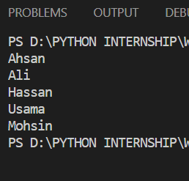

**Summary:**

In this program I learn logic about list. I Create a list that store 5 different name then I use print function to print each name separately by indexing as 0,1,2… up to 4.

2. Reverse list without reverse().

**Output:**

**Summary:**

In this program I create a list of different number and I create a variable reversed_list and I consider start and stop as a zero and I go back to step as a -1 that reverse my list without reverse method.

**TASK # 02**

1: Store 3 coordinates & unpack.

**Output:**

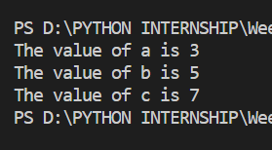

**Summary:**

In this program I used variable point and store 3 coordinate value into it. And I next step I assigned value a,b,c to point varaiable. And finally print values.

2. Swap vars using tuple assignment.

**Output:**

**Summary:**

I declare a variable and assign them 2 values in first step and in next step I swap values using tuple unpacking method and finally print.

**Task 03:**

1: Remove duplicates from list.

**Output:**

2. Find intersection of two sets.